**Deployment Preparation and Staging Report**

**Prepared by Aisha Junaid**

**Introduction**

Day 6 of our food tuck platform project focused on creating a robust staging environment to replicate real-world conditions. This process was critical for ensuring an error-free and seamless user experience. By following deployment best practices and conducting rigorous testing, we successfully prepared the platform for live operations.

**Objectives**

1. Establish a fully functional staging environment tailored to the food tuck ordering platform.
2. Ensure secure deployment configurations, safeguarding sensitive data.
3. Conduct comprehensive testing to validate all functionalities, performance, and security aspects.
4. Document and organize the deployment process for streamlined management and future references.

**Methodology**

**Hosting Platform Setup**

**Vercel** was chosen as the hosting platform due to its streamlined deployment pipelines and compatibility with real-time updates. Key steps included:

* Integrating the GitHub repository to automate builds and deployments.
* Configuring deployment settings to support backend functionalities like live menu updates, cart management, and order tracking.

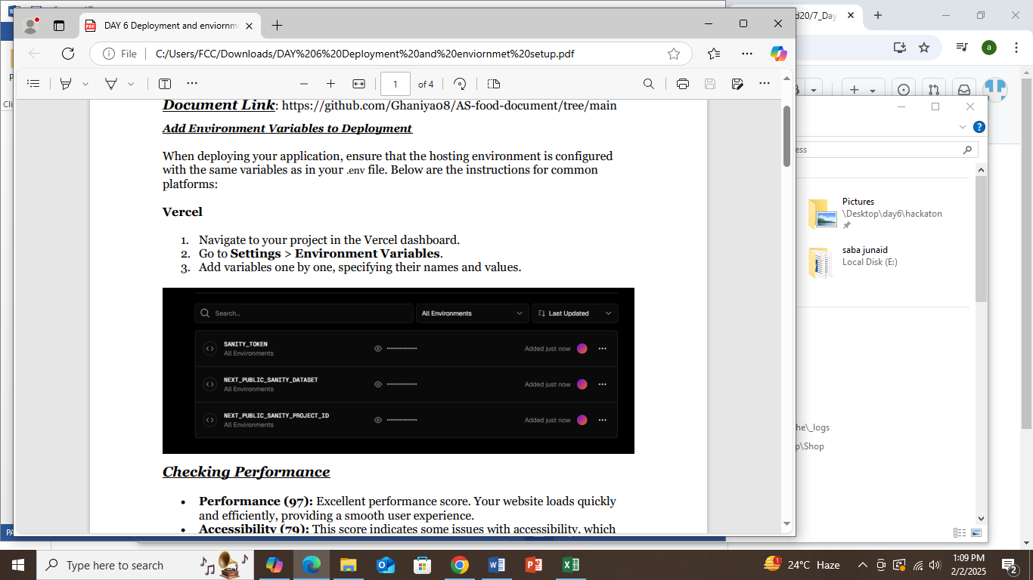

**Checking Performance**

• Performance (99): Excellent performance score. Your website loads quickly and efficiently, providing a smooth user experience.

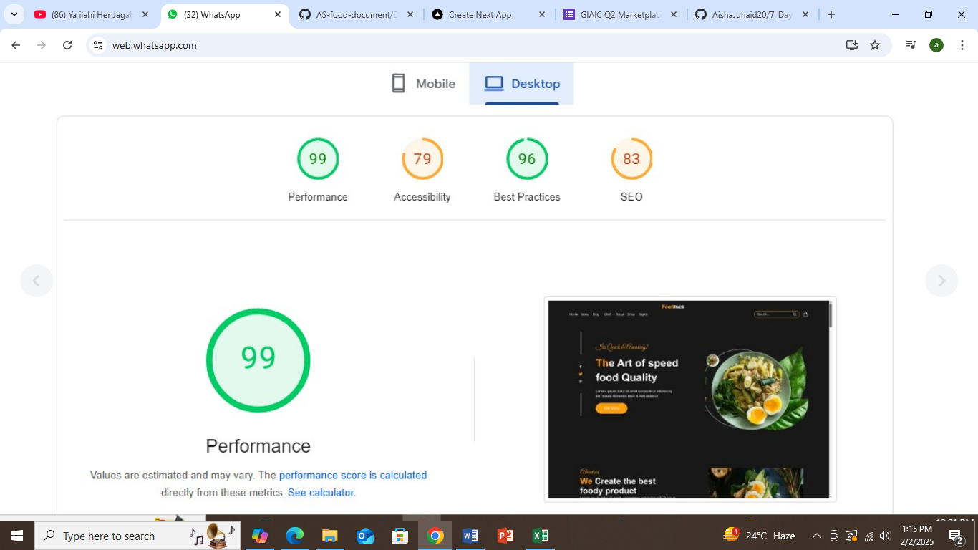

• Accessibility (87): This score indicates some issues with accessibility, which could make the site difficult for users with disabilities to navigate.

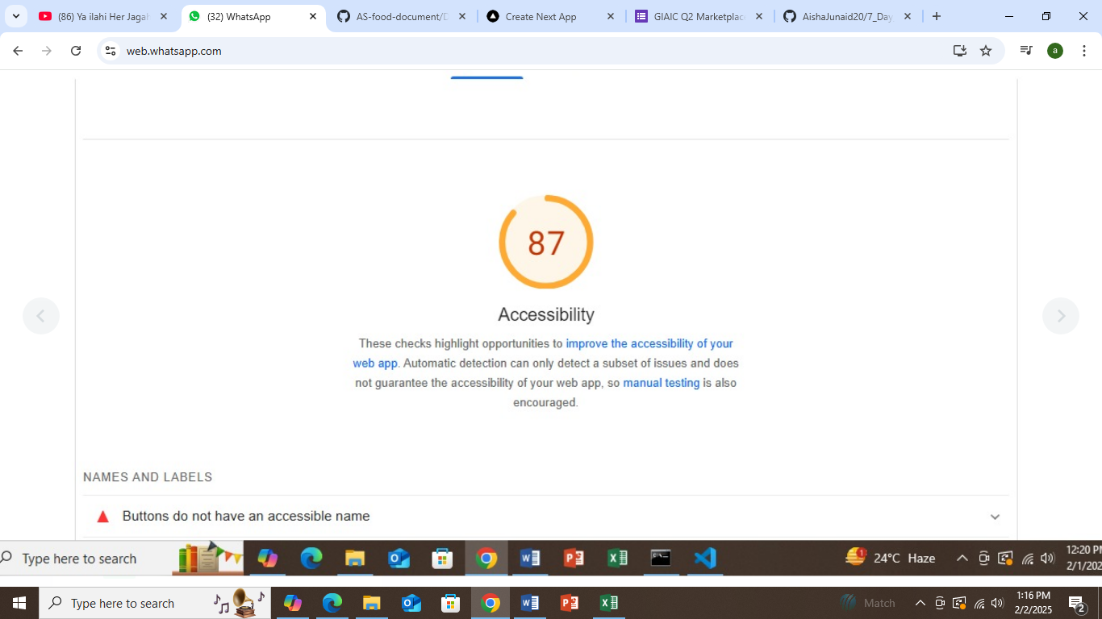

• Best Practices (93): Very good adherence to coding and security best practices. Only minor improvements might be needed.

• SEO (83): The site is reasonably optimized for search engines but could benefit from additional SEO improvements. To enhance your site's overall scores

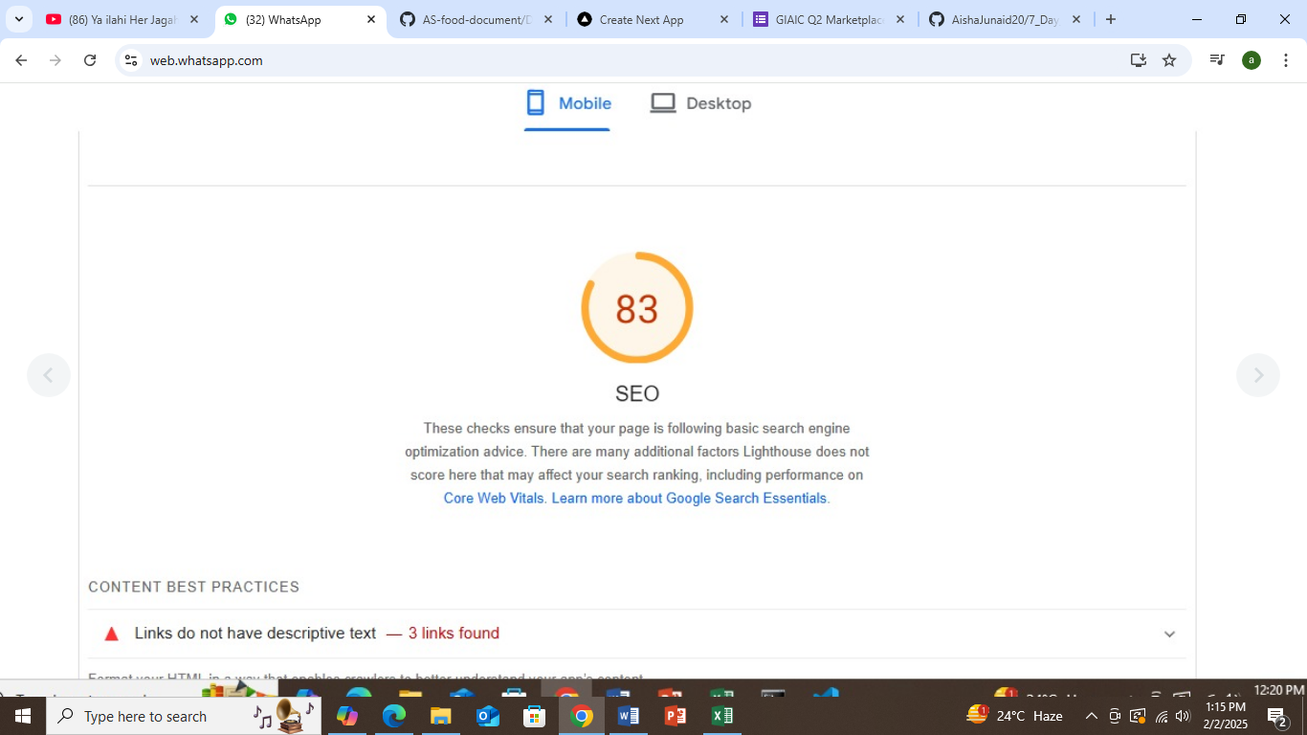

**Staging Deployment**

The platform was successfully deployed to a staging environment to simulate live conditions. This included:

* Validating core functionalities like food menu browsing, cart updates, and order placement.
* Ensuring seamless integration of backend APIs for inventory management and order processing.

**Testing and Validation**

Extensive testing was conducted to ensure the platform’s readiness for production:

1. **Functional Testing:**
   * Verified addition and removal of food items from the cart.
   * Ensured proper functioning of checkout and payment workflows.
2. **Performance Testing:**
   * Used **Lighthouse** to validate fast load times and responsiveness, especially under peak usage scenarios.
3. **Security Testing:**
   * Confirmed HTTPS encryption for secure data transmission.
   * Ensured safe handling of sensitive user information.

**Shared Chunks:** Indicates JavaScript files shared across multiple pages

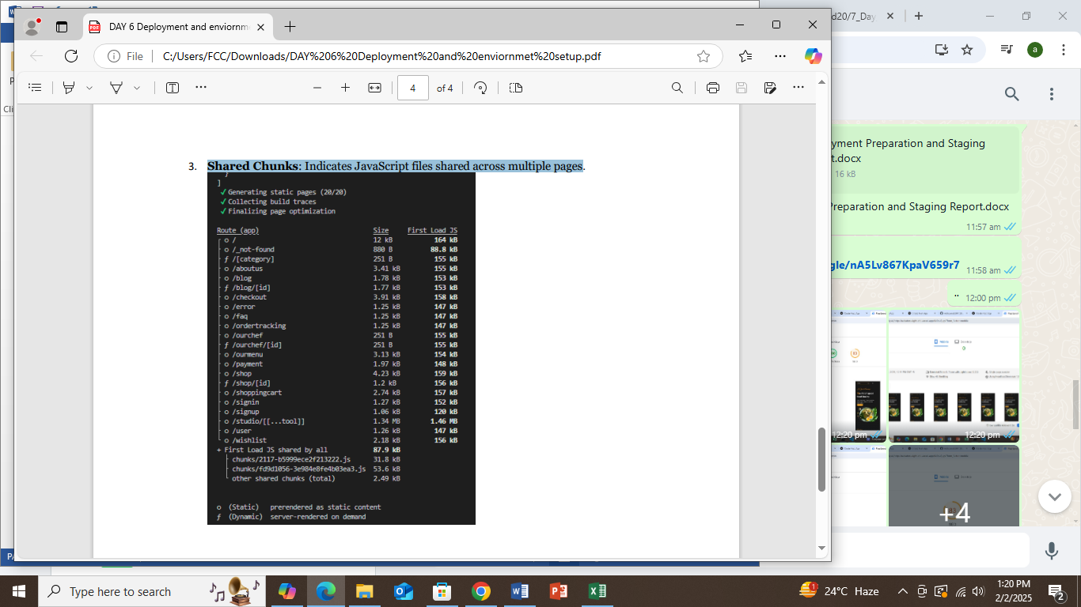

**Outcomes**

1. **Deployment Success:** The staging environment was fully deployed, closely replicating real-world conditions.
2. **Enhanced Security:** Environment variables and sensitive data were effectively managed to prevent unauthorized access.
3. **Reliable Platform:** Testing results ensured all key functionalities performed seamlessly.
4. **Organized Assets:** The project repository was structured for clarity, including a professional README.md summarizing the deployment process.

**Conclusion**

The successful deployment and testing of the staging environment mark a critical milestone for the food tuck platform. This preparation ensures a robust, user-friendly experience, laying the foundation for a smooth production launch. By addressing pre-launch challenges and leveraging best practices, we are well-positioned for ongoing improvements and scalability.

**Prepared by:** AISHA JUNAID